**Date:**

**Ex no:**  **Passport Automation System**

**1.1 Problem Statement :**

Passport Automation System is used in the effective dispatch of passport to all of the applicants. This system adopts a comprehensive approach to minimize the manual work and schedule resources, time in a cogent manner. The core of the system is to get the online registration form with details such as name, address etc., filled by the applicant whose testament is verified for its genuineness by the Passport Automation System with respect to the already existing information in the database.This forms the first and foremost step in the processing of passport application. After the first round of verification done by the system, the information is in turn forwarded to the regional administrator's Ministry of External Affairs office. The application is then processed manually based on the report given by the system, and any forfeiting identified can make the applicant liable to penalty as per the law. The system forwards the necessary details to the police for its separate verification whose report is then presented to the administrator. After all the necessary criteria have been met, the original information is added to the database and the passport is sent to the applicant.

Architecture diagram

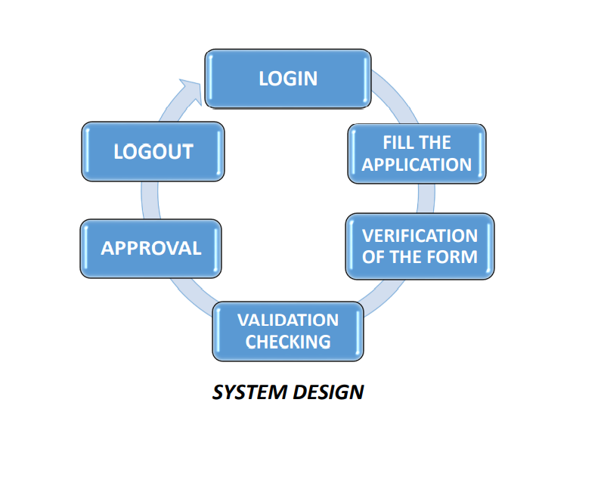

1.2 Software Requirements Specification

for

Passport Automation System

Prepared by Prasanth.c

13th March 2014

# Introduction

## Purpose

If the entire process of 'Issue of Passport' is done in a manual manner then it would take several months for the passport to reach the applicant. Considering the fact that the number of applicants for passport is increasing every year, an Automated System is essential to meet the demand. So this system uses several programming and database techniques to elucidate the work involved in this process. As this is a matter of National Security, the system has been carefully verified and validated in order to satisfy it.

## Product Scope

The System provides an online interface to the user where they can fill in their personal details. The authority concerned with the issue of passport can use this system to reduce his workload and process the application in a speedy manner. Provide a communication platform between the applicant and the administrator. Transfer of data between the Passport Issuing Authority and the Local Police for verification of applicant's information.

# Overall Description

## Product Functions

The PAS acts as an interface between the 'applicant' and the 'administrator'. This system tries to make the interface as simple as possible and at the same time not risking the security of data stored in. This minimizes the time duration in which the user receives the passport.

## Operating Environment

• **Front End Client** - The applicant and Administrator online interface is built using Microsoft Visual studio 2005.

• **Back End** –SQL

The server is directly connected to the client systems. The client systems have access to the database in the server.

**Software requirement:**

Client on the internet Web browser,operating system(any), .net frame work as a front end tool,operating system(any),webserver SQL operating system(any).rational rose for representing

Diagrams.

**Hardware requirement:**

Minimum Requirements: Processor RAM Disk Space

Recommended Requirements: Processor RAM Disk Space

It supports xp and more than xp.

# External Interface Requirements

## User Interfaces

• **Applicant** - They are the people who desires to obtain the passport and submit the information to the database.

• **Administrator** - He has the certain privileges to add the passport status and to approve the issue of passport. He may contain a group of persons under him to verify the documents and give suggestion whether or not to approve the dispatch of passport.

• **Police** - He is the person who upon receiving intimation from the PAS, perform a personal verification of the applicant and see if he has any criminal case against him before or at

present. He has been vetoed with the power to decline an application by suggesting it to the Administrator if he finds any discrepancy with the applicant. He communicates via this PAS.

## Software Interfaces

Client on the internet Web browser,operating system(any), .net frame work as a front end tool,operating system(any),webserver SQL operating system(any).rational rose for representing

Diagrams.

# System Features

Secure Registration of information by the Applicants.Message box for Passport Application Status Display by the Administrator. Administrator can generate reports from the information and is the only authorized personnel to add the eligible application information to the database.

## Filling Details

### Description and Priority

The user needs to fill their details properly as verification is based on that.It has the highest priority in the system.

### Stimulus/Response Sequences

* The user enters all the details in the form.
* If all fields all filled then system returns the success message that details are entered

**4.1.3 Functional Requirements:**

* It is defined as how the system should react in the particular input and how the system should react in particular situations and what the system do not do.
* In my project ,login as functional requirement.in that functional requirement we may check the user name and password is correct or not .after checking entity of login ,we can show the detail based on type of actor.

## Verification

**4.2.1 Description and Priority:**

The verification is done by the regional administrator after the information provided by the user.It has the highest priority in the system.

### Stimulus/Response Sequences:

* .The verification is done on the administrator side and if valid then passport will be issued
* If the verification respond as invalid then ask the user to reapply the passport.

# Other Nonfunctional Requirements

## Performance Requirements

* The response time of the system should be less.The applicant uder the criminal act are not allowed to issue passport .
* Sometimes the workload will be high,that is in certain period the application will be high and sometime it will be less,then it should be managed properly by employing more staffs to process the system.
* Administrator warrants that this system shall be capable of supporting atleast 1000 customers per day.

## Security Requirements

Every user is provided with unique ID with their password.Every user is authenticated before accessing their account.If authentication doesn’t provided then illegal usage of passport will occur.

## Software Quality Attributes

* The system is highly reliable.
* The system is also adaptable under any conditions.

## Business Rules

To get the passport the address proof and age proof should be provided and the applicant should be free of criminal case.

**1.3 Use Case Diagram**



Fig: 1.3.1

**Additional Features:**



Fig: 1.3.2

**Description:**

**In passport automation system :**

The actors used in use case diagram are applicant,passport officer.The usecases used are online form,validation,appointment,verification,status,delivery.In online form we get user’s application and later we validate using validation usecase then the applicant will get appointment for enquiry they will verify the details and in delivery usecase they will issue the passport.

**In additional features :**

we add several usecases to the verification.where the verification usecase has certificate verification,photographs,original document,enquiry,it also includes document scanning and extends reappointment.

**1.4 Activity Diagram :**



Fig: 1.4.1

**Description:**

In activity diagram the activities in the passport automation system are login, submit details, get details, issue passport and penalty and verification. In the login activity applicant give username and password and then login into the passport automation system after then fill the details that are required for application.After the verification procedure completed successfully the passport is issued to the applicant.

**1.5**  **Class Diagram**

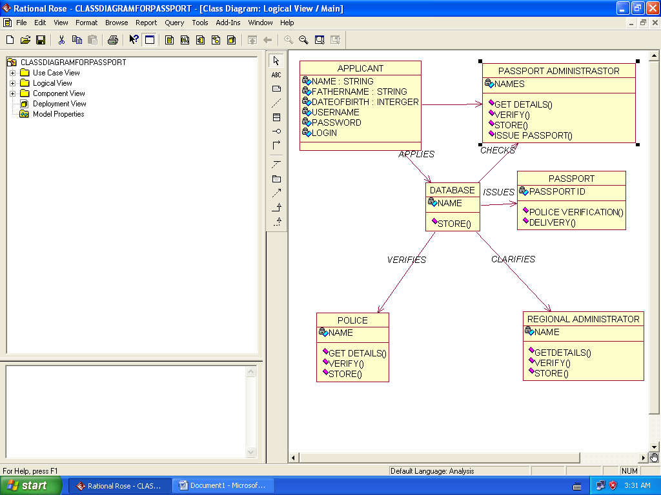

Fig: 1.5.1

**Description:**

**Applicant**- The applicant has attribute such as name and password and operations are login, givedetails and logout. The applicant login and fill the details that are required for applying the passport .After applying the person can view the status of the passport verification process

**The Database**- The database has attributed such as name and operation is store. The purpose is to store the data.

**Regional Administrator**- The regional administrator has attribute such as name and operation are get details, verify details and send. The regional administrator get the details form database and verify with their database.

**Passport Administrator**- The passport administrator has attributed such as name and operation are get details, verify details and issue. The passport administrator get the details form database and verify with their database , update the verification and issue the passport.

**The Police**- The police has attribute such as name and operation are get details, verify details and send. The police get the details form database and verify with their database , update the verification in the database.

**1.6 Interaction Diagram**

**1.6 a) Sequence Diagram**

**Valid Passport Pin:**



Fig:1.6.1

**Invalid Passport Pin :**

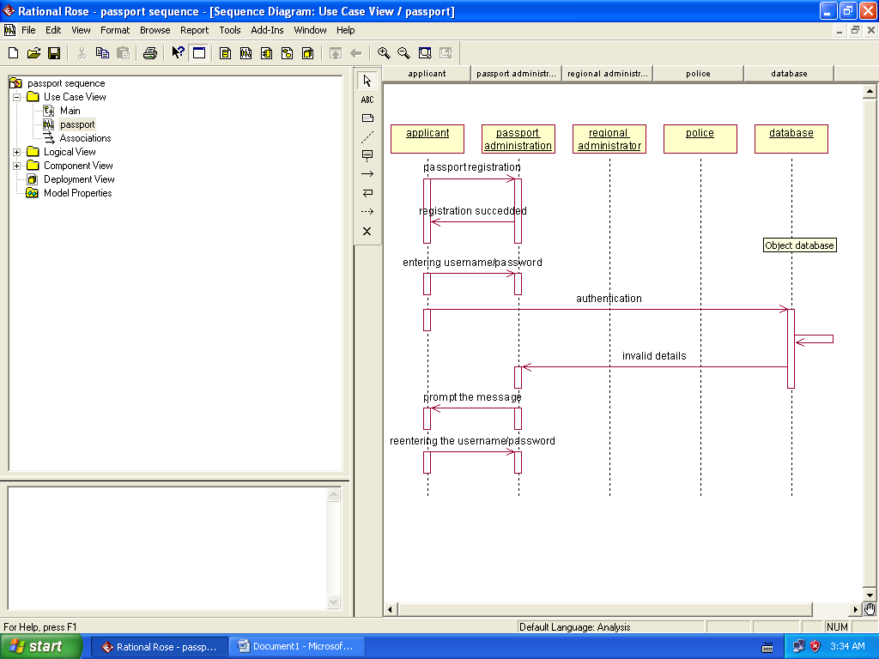

Fig: 1.6.2

**Description:**

The applicant login the database and give his details and database store the details. The passport administrator get the details from the database and do verification and the forward to regional administrator. The regional administrator get details form passport administrator and perform verification and send report to passport administrator.The police get the details form passport administrator and perform verification and send report to passport administrator .

**1.6 b) Collabration Diagram**

**Valid Passport Pin :**



Fig: 1.6.3

**Invalid Passport Pin :**



Fig: 1.6.4

**Description:**

The applicant, passport administrator, regional administrator and database functions are show in sequence number . The applicant first login the passport automation system and submit his details the passport administrator, regional administrator are denoted.

**1.7 State Chart Diagram**



Fig:1.7.1

**Description:**

The states of the passport automation system are denoted in the state chart diagram home page state represent authentication for login the passport automation system In this state, it checks whether the applicant has provided all the details that is required. Police regional administrator and passport administrator get necessary details and verification of the applicant are denoted from the Get detail state and verification state.

**1.8 Package Diagram**



Fig:1.8.1

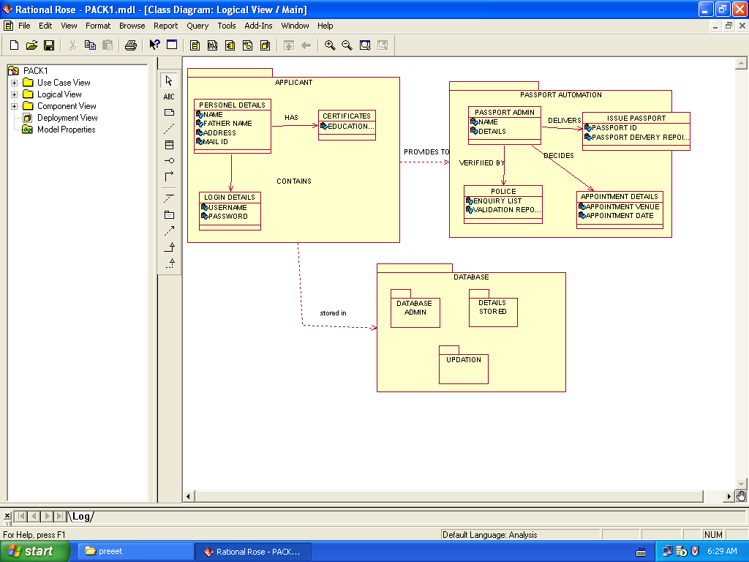

Fig: 1.8.2

**Description:**

In package diagram we have three different packages.In applicant package we have personal details,certification,login details class.In passport automation system package we have passport admin,issue passport,police,appointment details class.Applicant package provides details to passport automation package.All details of applicant is being stored in database package.where database package consists of database admin,details stored and updation packages.

**1.9 Design Of User Interface & Implementation Of Domain & Technical Services Layer**

**Form :**

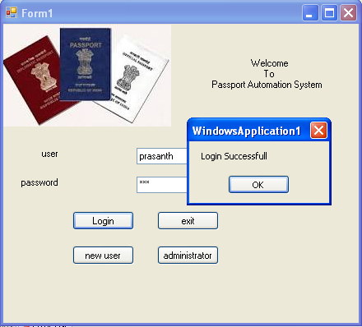

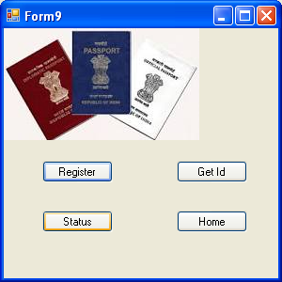

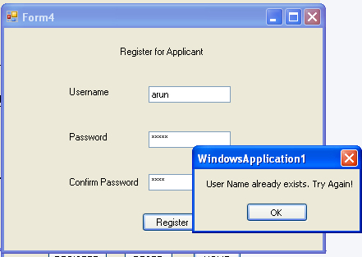

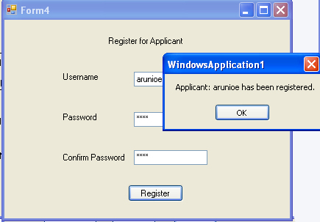

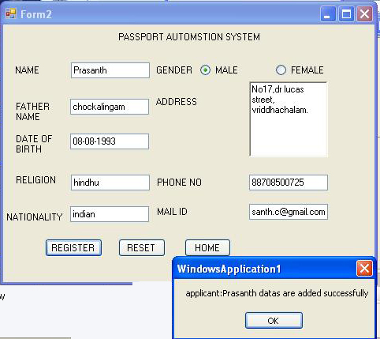

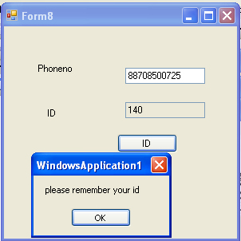

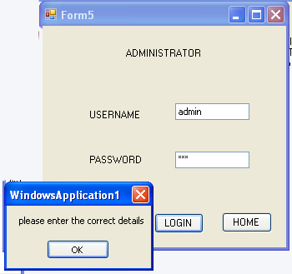

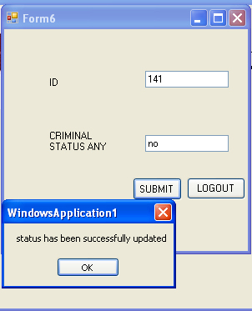

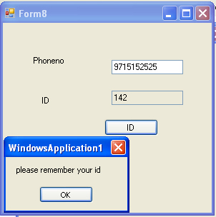

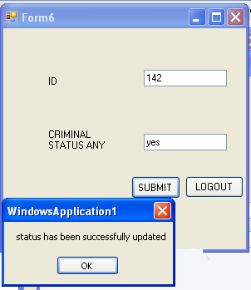

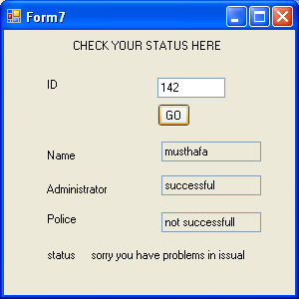

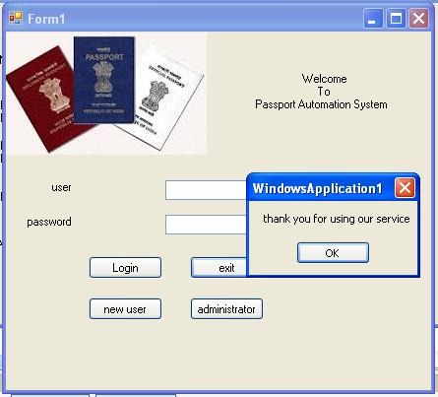

**Form Related Tables :**

**Table Creation**

**1.userid :**

Create table userid(unamevarchar(25),upassvarchar(15))

**Entries of userid**

Select * from userid

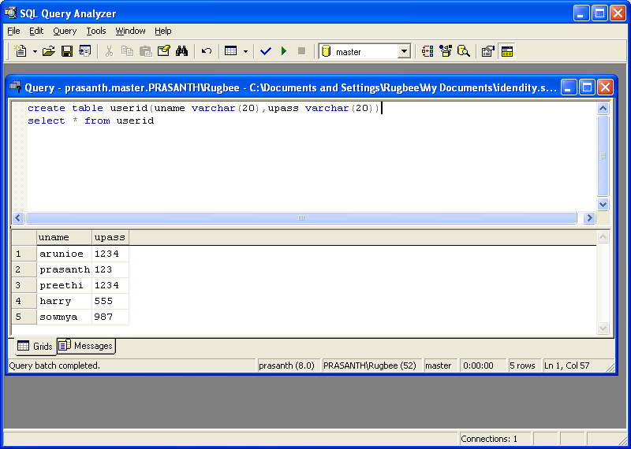

**2.Table:details**

Create table details(id integer identity(100,1) primary key,namevarchar(15),fathernamevarchar(20),dateofbirthvarchar(15),religion varchar(15), nationality varchar(15), gender varchar(10),address varchar(50), phonenovarchar(20) mail_Idvarchar(20), status varchar(20))

**Entries of details**

Select * from details

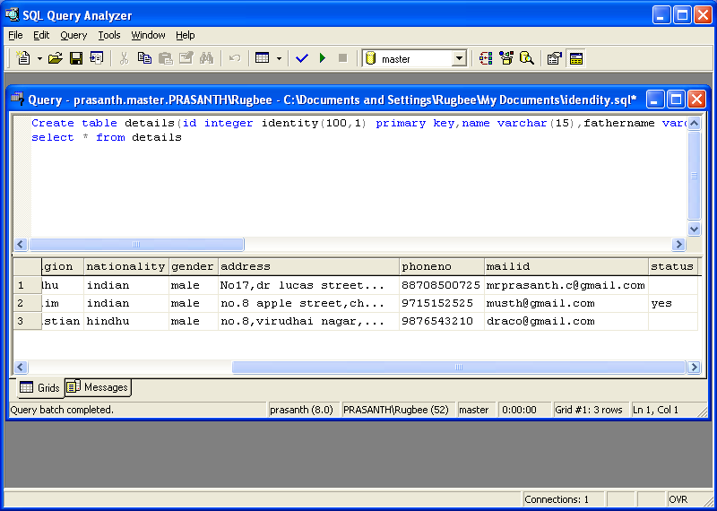

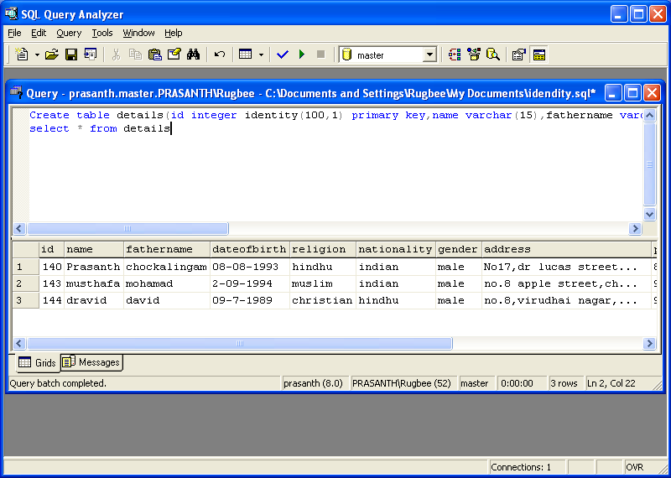

**Code :**

**Form 1 :**

Imports System.Data.SqlClient

Public Class Form1

Public con As SqlConnection

Public cmd As SqlCommand

Public drAsSqlDataReader

Private Sub Form1_Load(ByVal sender As System.Object, ByVal e As System.EventArgs) Handles MyBase.Load

con = New SqlConnection("Data Source=prasanth;InitialCatalog=master;Integrated Security=True")

End Sub

Private Sub Button1_Click(ByVal sender As System.Object, ByVal e As System.EventArgs) Handles Button1.Click

Try

con.Open()

cmd = New SqlCommand("select uname,upass from userid where uname='" + TextBox1.Text + "'and upass='" + TextBox2.Text + "'", con)

dr = cmd.ExecuteReader

If (dr.Read()) Then

MsgBox("Login Successfull")

Me.Hide()

Form9.Show()

Else

MsgBox("Unauthenticate User!")

TextBox1.Text = ""

TextBox2.Text = ""

TextBox1.Focus()

End If

dr.Close()

con.Close()

Catch ex As Exception

MsgBox(ex.Message.ToString)

End Try

End Sub

Private Sub Button4_Click(ByVal sender As System.Object, ByVal e As System.EventArgs) Handles Button4.Click

Dim form5 As New Form5

form5.Show()

End Sub

Private Sub Button3_Click(ByVal sender As System.Object, ByVal e As System.EventArgs) Handles Button3.Click

Me.Hide()

Form4.Show()

End Sub

Private Sub Button2_Click(ByVal sender As System.Object, ByVal e As System.EventArgs) Handles Button2.Click

MsgBox("thank you for using our service")

Form3.Show()

End Sub

Private Sub PictureBox1_Click(ByVal sender As System.Object, ByVal e As System.EventArgs) Handles PictureBox1.Click

End Sub

End Class

**Form 2 :**

Imports System.Data.SqlClient

Public Class Form2

Dim cmd As SqlCommand

Dim con As SqlConnection

Dim drAsSqlDataReader

Dim ge As String

Private Sub Form1_Load(ByVal sender As System.Object, ByVal e As System.EventArgs) Handles MyBase.Load

con = New SqlConnection("Data Source=prasanth;InitialCatalog=master;Integrated Security=True")

End Sub

Private Sub Button1_Click(ByVal sender As System.Object, ByVal e As System.EventArgs) Handles Button1.Click

Try

con.Open()

If (RadioButton1.Checked = True) Then

ge = "male"

Else

ge = "female"

End If

cmd = New SqlCommand("insert into details values('" + TextBox1.Text + "','" + TextBox2.Text + "','" + TextBox3.Text + "','" + TextBox4.Text + "','" + TextBox5.Text + "','" + ge + "','" + RichTextBox1.Text + "','" + TextBox6.Text + "','" + TextBox7.Text + "','')", con)

cmd.ExecuteNonQuery()

MsgBox("applicant:" + TextBox1.Text + " datas are added successfully")

con.Close()

Catch ex As Exception

MsgBox(ex.Message.ToString)

End Try

End Sub

Private Sub Button2_Click(ByVal sender As System.Object, ByVal e As System.EventArgs) Handles Button2.Click

Dim form1 As New Form1

form1.Show()

End Sub

Private Sub Button3_Click(ByVal sender As System.Object, ByVal e As System.EventArgs) Handles Button3.Click

TextBox1.Text = ""

TextBox2.Text = ""

TextBox3.Text = ""

TextBox4.Text = ""

TextBox5.Text = ""

RichTextBox1.Text = ""

TextBox6.Text = ""

TextBox7.Text = ""

TextBox1.Focus()

End Sub

Private Sub Button4_Click(ByVal sender As System.Object, ByVal e As System.EventArgs)

Me.Hide()

Form7.Show()

End Sub

Private Sub Form1_PaddingChanged(ByVal sender As Object, ByVal e As System.EventArgs) Handles Me.PaddingChanged

End Sub

Private Sub TextBox3_TextChanged(ByVal sender As System.Object, ByVal e As System.EventArgs) Handles TextBox3.TextChanged

End Sub

Private Sub Button6_Click(ByVal sender As System.Object, ByVal e As System.EventArgs)

dim form8 As New Form8

form8.Show()

End Sub

Private Sub Button5_Click(ByVal sender As System.Object, ByVal e As System.EventArgs)

End Sub

End Class

**Form 3 :**

Public Class Form3

Private Sub Label1_Click(ByVal sender As System.Object, ByVal e As System.EventArgs) Handles Label1.Click

End Sub

Private Sub Button1_Click(ByVal sender As System.Object, ByVal e As System.EventArgs) Handles Button1.Click

Dim form1 As New Form1

form1.Show()

End Sub

Private Sub Form3_Load(ByVal sender As System.Object, ByVal e As System.EventArgs) Handles MyBase.Load

End Sub

End Class

**Form 4 :**

Imports System.Data.SqlClient

Public Class Form4

Dim con4 As SqlConnection

Dim cmd4 As SqlCommand

Dim dr4 As SqlDataReader

Dim getcount As String

Private Sub Form4_Load(ByVal sender As System.Object, ByVal e As System.EventArgs) Handles MyBase.Load

con4 = New SqlConnection("Data Source=prasanth;InitialCatalog=master;Integrated Security=True")

End Sub

Private Sub Button1_Click(ByVal sender As System.Object, ByVal e As System.EventArgs) Handles Button1.Click

Try

con4.Open()

cmd4 = New SqlCommand("select count(*) from userid where uname='" + TextBox1.Text + "'", con4)

dr4 = cmd4.ExecuteReader

If dr4.Read = True Then

getcount = dr4(0)

dr4.Close()

If getcount<> 0 Then

MsgBox("User Name already exists. Try Again!")

TextBox1.Text = ""

TextBox2.Text = ""

TextBox3.Text = ""

TextBox1.Focus()

Else

If TextBox2.Text = TextBox3.Text Then

cmd4 = New SqlCommand("insert into userid values('" + TextBox1.Text + "','" + TextBox2.Text + "')", con4)

cmd4.ExecuteNonQuery()

MsgBox("Applicant: " + TextBox1.Text + " has been registered.")

Me.Hide()

Form1.Show()

ElseIf TextBox2.Text <> TextBox3.Text Then

MsgBox("Password was mismatch")

TextBox2.Text = ""

TextBox3.Text = ""

TextBox2.Focus()

End If

End If

End If

con4.Close()

Catch ex As Exception

MsgBox(ex.Message.ToString)

End Try

End Sub

End Class

**Form 5 :**

Public Class Form5

Private Sub Button2_Click(ByVal sender As System.Object, ByVal e As System.EventArgs) Handles Button2.Click

Dim form1 As New Form1

form1.Show()

End Sub

Private Sub Form5_Load(ByVal sender As System.Object, ByVal e As System.EventArgs) Handles MyBase.Load

End Sub

Private Sub Button1_Click(ByVal sender As System.Object, ByVal e As System.EventArgs) Handles Button1.Click

If (TextBox1.Text = "admin" And TextBox2.Text = "admin") Then

Dim form6 As New Form6

Me.Hide()

form6.Show()

Else

MsgBox("please enter the correct details")

TextBox1.Text = ""

TextBox2.Text = ""

TextBox1.Focus()

End If

End Sub

End Class

**Form 6 :**

Imports System.Data.SqlClient

Public Class Form6

Dim con As SqlConnection

Dim cmd As SqlCommand

Private Sub Button2_Click(ByVal sender As System.Object, ByVal e As System.EventArgs) Handles Button2.Click

Dim form1 As New Form1

form1.Show()

End Sub

Private Sub Button1_Click(ByVal sender As System.Object, ByVal e As System.EventArgs) Handles Button1.Click

con.Open()

cmd = New SqlCommand("update details set status='" + TextBox2.Text + "' where id='" + TextBox1.Text + "'", con)

cmd.ExecuteNonQuery()

MsgBox("status has been successfully updated")

con.Close()

End Sub

Private Sub Form6_Load(ByVal sender As System.Object, ByVal e As System.EventArgs) Handles MyBase.Load

con = New sqlconnection("Data Source=prasanth;InitialCatalog=master;Integrated Security=True")

End Sub

End Class

**Form 7 :**

Imports System.Data.SqlClient

Public Class Form7

Public con As SqlConnection

Public cmd As SqlCommand

Public drAsSqlDataReader

Public name1 As String

Public stat As String

Private Sub TextBox2_TextChanged(ByVal sender As System.Object, ByVal e As System.EventArgs) Handles TextBox2.TextChanged

End Sub

Private Sub Button1_Click(ByVal sender As System.Object, ByVal e As System.EventArgs) Handles Button1.Click

Try

con.Open()

cmd = New SqlCommand("select status,name from details where id='" + TextBox1.Text + "'", con)

dr = cmd.ExecuteReader

If (dr.Read()) Then

stat = dr(0)

name1 = dr(1)

End If

TextBox2.Text = name1

TextBox3.Text = "successful"

If (stat = "no") Then

TextBox4.Text = "successfull"

Label8.Text = "your passport will be issued soon"

Else

TextBox4.Text = "not successfull"

Label8.Text = "sorry you have problems in issual"

End If

Catch ex As Exception

MsgBox(ex.Message.ToString)

End Try

con.Close()

End Sub

Private Sub Form7_Load(ByVal sender As System.Object, ByVal e As System.EventArgs) Handles MyBase.Load

TextBox2.ReadOnly = True

TextBox3.ReadOnly = True

TextBox4.ReadOnly = True

Label8.Text = "."

con = New SqlConnection("Data Source=prasanth;InitialCatalog=master;Integrated Security=True")

End Sub

Private Sub Label7_Click(ByVal sender As System.Object, ByVal e As System.EventArgs) Handles Label7.Click

End Sub

Private Sub Label8_Click(ByVal sender As System.Object, ByVal e As System.EventArgs) Handles Label8.Click

End Sub

End Class

**Form 8 :**

Imports System.Data.SqlClient

Public Class Form8

Public con As SqlConnection

Dim drAsSqlDataReader

Public cmd As SqlCommand

Dim idno As Integer

Private Sub Button1_Click(ByVal sender As System.Object, ByVal e As System.EventArgs) Handles Button1.Click

Try

con.Open()

cmd = New SqlCommand("select id from details where phoneno='" + TextBox1.Text + "'", con)

dr = cmd.ExecuteReader

While dr.Read = True

idno = dr(0)

TextBox2.Text = idno

MsgBox("please remember your id")

End While

Catch ex As Exception

End Try

con.Close()

End Sub

Private Sub Form8_Load(ByVal sender As System.Object, ByVal e As System.EventArgs) Handles MyBase.Load

TextBox2.ReadOnly = True

con = New SqlConnection("Data Source=prasanth;InitialCatalog=master;Integrated Security=True")

End Sub

End Class

**Form 9 :**

Public Class Form9

Private Sub Button4_Click(ByVal sender As System.Object, ByVal e As System.EventArgs) Handles Button4.Click

Dim form7 As New Form7

form7.Show()

End Sub

Private Sub Button1_Click(ByVal sender As System.Object, ByVal e As System.EventArgs) Handles Button1.Click

Dim form2 As New Form2

form2.Show()

End Sub

Private Sub Button3_Click(ByVal sender As System.Object, ByVal e As System.EventArgs) Handles Button3.Click

Dim form8 As New Form8

form8.Show()

End Sub

Private Sub Button2_Click(ByVal sender As System.Object, ByVal e As System.EventArgs) Handles Button2.Click

Dim form1 As New Form1

form1.Show()

End Sub

End Class

**1.10 Implementation Diagram**

**1.10 a) Component Diagram**

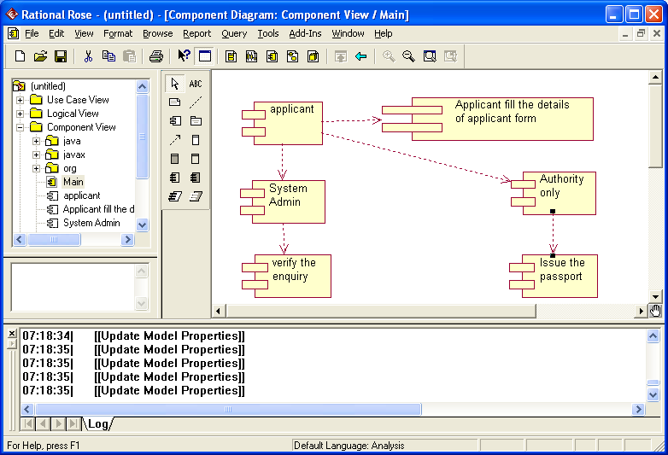

Fig: 1.10.1

**Description:**

The applicant,System Admin,enquiry verification are components being interacted with another component authority which issue the passport.

**1.10 b) Deployment Diagram**

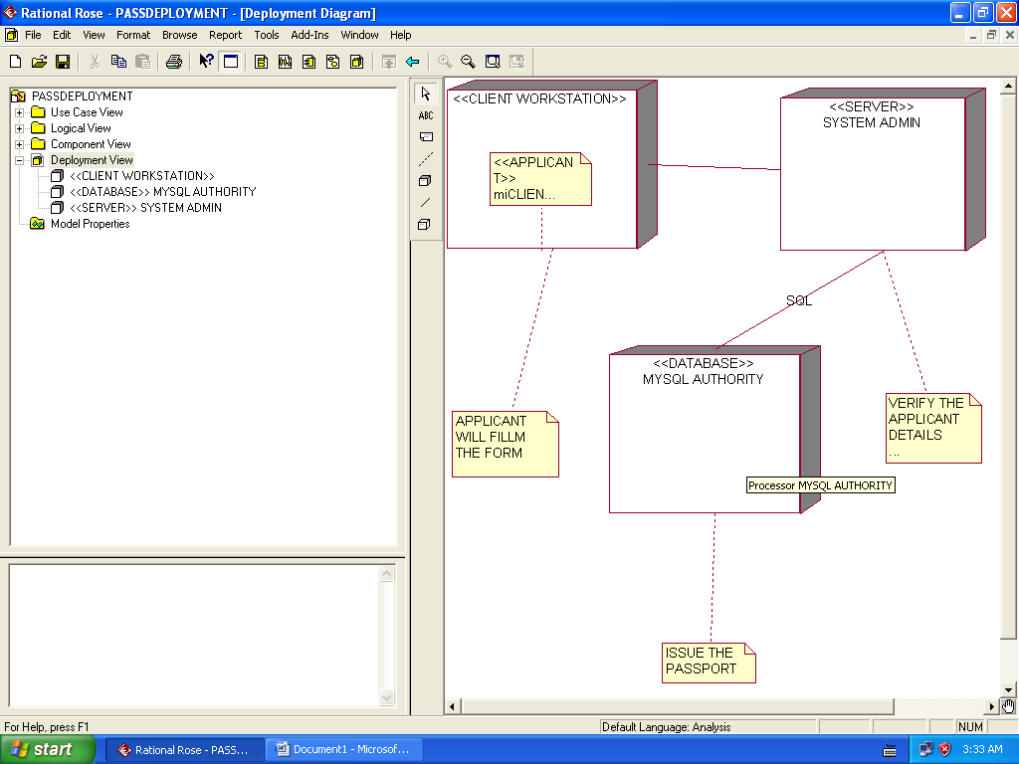

Fig: 1.10.2

**Description:**

In deployment diagram client workstation is being connected with server system admin.The server connected with database an authority store.the database will store all the details and issue the passport.